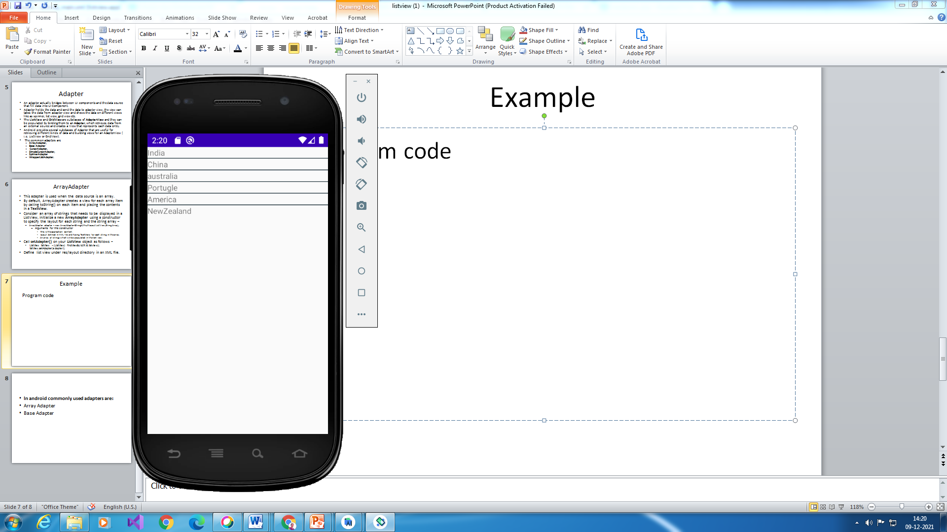

*/res/activity.xml*

*<?*xml version="1.0" encoding="utf-8"*?>*<LinearLayout xmlns:android="http://schemas.android.com/apk/res/android"  
 android:layout_width="match_parent"  
 android:layout_height="match_parent"  
 android:orientation="vertical">  
  
 <ListView  
 android:id="@+id/simpleListView"  
 android:layout_width="fill_parent"  
 android:layout_height="wrap_content"  
 android:divider="@color/material_blue_grey_800"  
 android:dividerHeight="1dp" />  
</LinearLayout>

/res/layout

/activity_activitylistview.xml

*<?*xml version="1.0" encoding="utf-8"*?>*<LinearLayout xmlns:android="http://schemas.android.com/apk/res/android"  
 android:layout_width="match_parent"  
 android:layout_height="match_parent"  
 android:orientation="vertical">  
  
 <TextView  
 android:id="@+id/textView"  
 android:layout_width="fill_parent"  
 android:layout_height="wrap_content"  
 android:layout_gravity="center"  
 />  
</LinearLayout>

.java file

package com.example.listview;  
import android.os.Bundle;  
import android.app.Activity;  
import android.widget.ArrayAdapter;import android.widget.ListView;  
public class MainActivity extends Activity  
{  
 *// Array of strings...* ListView simpleList;  
 String countryList[] = {"India", "China", "australia", "Portugle", "America", "NewZealand"};  
  
 @Override protected void onCreate(Bundle savedInstanceState) {  
 super.onCreate(savedInstanceState); setContentView(R.layout.*activity_main*);  
 simpleList = (ListView)findViewById(R.id.*simpleListView*);  
 ArrayAdapter<String> arrayAdapter = new ArrayAdapter<String>(this, R.layout.*activity_activitylistview*, R.id.*textView*, countryList);  
 simpleList.setAdapter(arrayAdapter);  
 }  
}

custom listview example 2

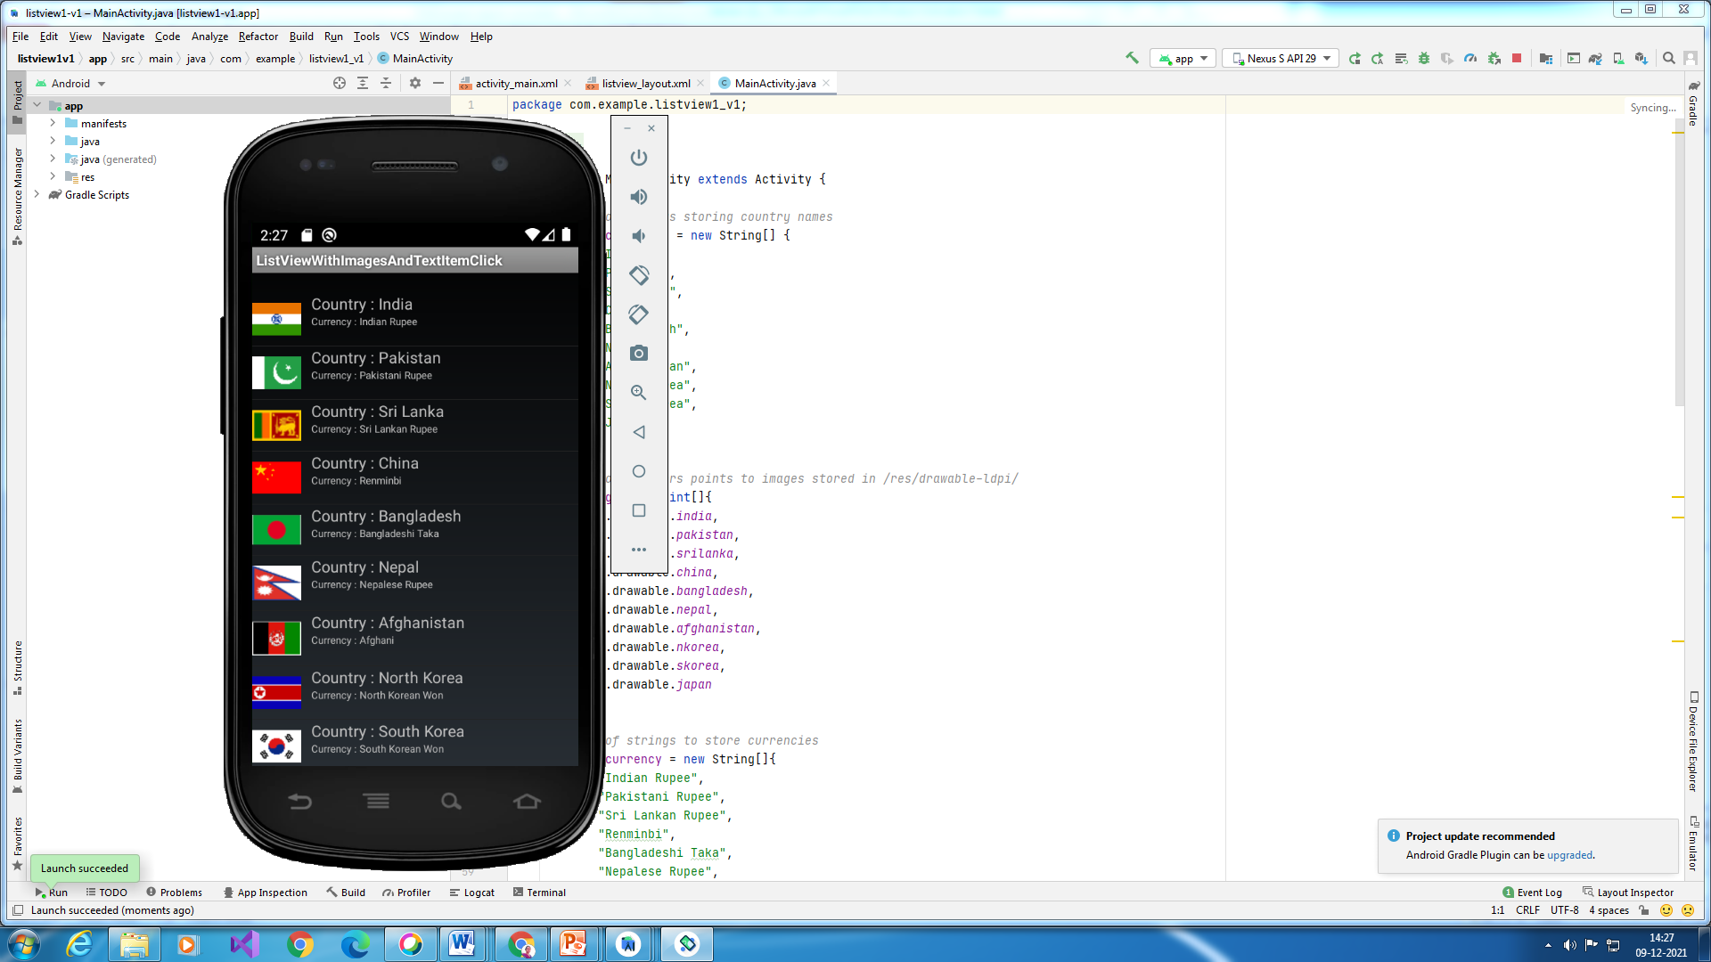

*<?*xml version="1.0" encoding="utf-8"*?>*<LinearLayout xmlns:android="http://schemas.android.com/apk/res/android"  
 android:layout_width="fill_parent"  
 android:layout_height="fill_parent"  
 android:orientation="vertical" >  
  
 <TextView  
 android:id="@+id/textview"  
 android:layout_width="fill_parent"  
 android:layout_height="wrap_content" />  
  
 <ListView  
 android:id="@+id/listview"  
 android:layout_width="fill_parent"  
 android:layout_height="wrap_content" />  
  
</LinearLayout>

/res/layout/listviewlayout.xml

*<?*xml version="1.0" encoding="utf-8"*?>*<LinearLayout xmlns:android="http://schemas.android.com/apk/res/android"  
 android:layout_width="match_parent"  
 android:layout_height="match_parent"  
 android:orientation="horizontal" >  
  
 <ImageView  
 android:id="@+id/flag"  
 android:layout_width="wrap_content"  
 android:layout_height="wrap_content"  
 android:contentDescription="@string/hello"  
 android:paddingTop="10dp"  
 android:paddingRight="10dp"  
 android:paddingBottom="10dp" />  
  
 <LinearLayout  
 android:layout_width="match_parent"  
 android:layout_height="match_parent"  
 android:orientation="vertical" >  
  
 <TextView  
 android:id="@+id/txt"  
 android:layout_width="wrap_content"  
 android:layout_height="wrap_content"  
 android:textSize="15dp" />  
  
 <TextView  
 android:id="@+id/cur"  
 android:layout_width="wrap_content"  
 android:layout_height="wrap_content"  
 android:textSize="10dp" />  
 </LinearLayout>  
</LinearLayout>

.java file

package com.example.listview1_v1;  
  
import androidx.appcompat.app.AppCompatActivity;  
  
import android.os.Bundle;  
import java.util.ArrayList;  
import java.util.HashMap;  
import java.util.List;  
  
import android.app.Activity;  
import android.os.Bundle;  
import android.view.Menu;  
import android.view.View;  
import android.widget.AdapterView;  
import android.widget.AdapterView.OnItemClickListener;  
import android.widget.LinearLayout;  
import android.widget.ListView;  
import android.widget.SimpleAdapter;  
import android.widget.TextView;  
import android.widget.Toast;  
  
public class MainActivity extends Activity {  
  
 *// Array of strings storing country names* String[] countries = new String[] {  
 "India",  
 "Pakistan",  
 "Sri Lanka",  
 "China",  
 "Bangladesh",  
 "Nepal",  
 "Afghanistan",  
 "North Korea",  
 "South Korea",  
 "Japan"  
 };  
  
 *// Array of integers points to images stored in /res/drawable-ldpi/* int[] flags = new int[]{  
 R.drawable.*india*,  
 R.drawable.*pakistan*,  
 R.drawable.*srilanka*,  
 R.drawable.*china*,  
 R.drawable.*bangladesh*,  
 R.drawable.*nepal*,  
 R.drawable.*afghanistan*,  
 R.drawable.*nkorea*,  
 R.drawable.*skorea*,  
 R.drawable.*japan* };  
  
 *// Array of strings to store currencies* String[] currency = new String[]{  
 "Indian Rupee",  
 "Pakistani Rupee",  
 "Sri Lankan Rupee",  
 "Renminbi",  
 "Bangladeshi Taka",  
 "Nepalese Rupee",  
 "Afghani",  
 "North Korean Won",  
 "South Korean Won",  
 "Japanese Yen"  
 };  
  
 */** Called when the activity is first created. */* @Override  
 public void onCreate(Bundle savedInstanceState) {  
 super.onCreate(savedInstanceState);  
 setContentView(R.layout.*activity_main*);  
  
 *// Each row in the list stores country name, currency and flag* List<HashMap<String,String>> aList = new ArrayList<HashMap<String,String>>();  
  
 for(int i=0;i<10;i++){  
 HashMap<String, String> hm = new HashMap<String,String>();  
 hm.put("txt", "Country : " + countries[i]);  
 hm.put("cur","Currency : " + currency[i]);  
 hm.put("flag", Integer.*toString*(flags[i]) );  
 aList.add(hm);  
 }  
  
 *// Keys used in Hashmap* String[] from = { "flag","txt","cur" };  
  
 *// Ids of views in listview_layout* int[] to = { R.id.*flag*,R.id.*txt*,R.id.*cur*};  
  
 *// Instantiating an adapter to store each items  
 // R.layout.listview_layout defines the layout of each item* SimpleAdapter adapter = new SimpleAdapter(getBaseContext(), aList, R.layout.*listview_layout*, from, to);  
  
 *// Getting a reference to listview of main.xml layout file* ListView listView = ( ListView ) findViewById(R.id.*listview*);  
  
 *// Setting the adapter to the listView* listView.setAdapter(adapter);  
  
 *// Item Click Listener for the listview* OnItemClickListener itemClickListener = new OnItemClickListener() {  
 @Override  
 public void onItemClick(AdapterView<?> parent, View container, int position, long id) {  
 *// Getting the Container Layout of the ListView* LinearLayout linearLayoutParent = (LinearLayout) container;  
  
 *// Getting the inner Linear Layout* LinearLayout linearLayoutChild = (LinearLayout ) linearLayoutParent.getChildAt(1);  
  
 *// Getting the Country TextView* TextView tvCountry = (TextView) linearLayoutChild.getChildAt(0);  
  
 Toast.*makeText*(getBaseContext(), tvCountry.getText().toString(), Toast.*LENGTH_LONG*).show();  
 }  
 };  
  
 *// Setting the item click listener for the listview* listView.setOnItemClickListener(itemClickListener);  
 }  
  
  
}

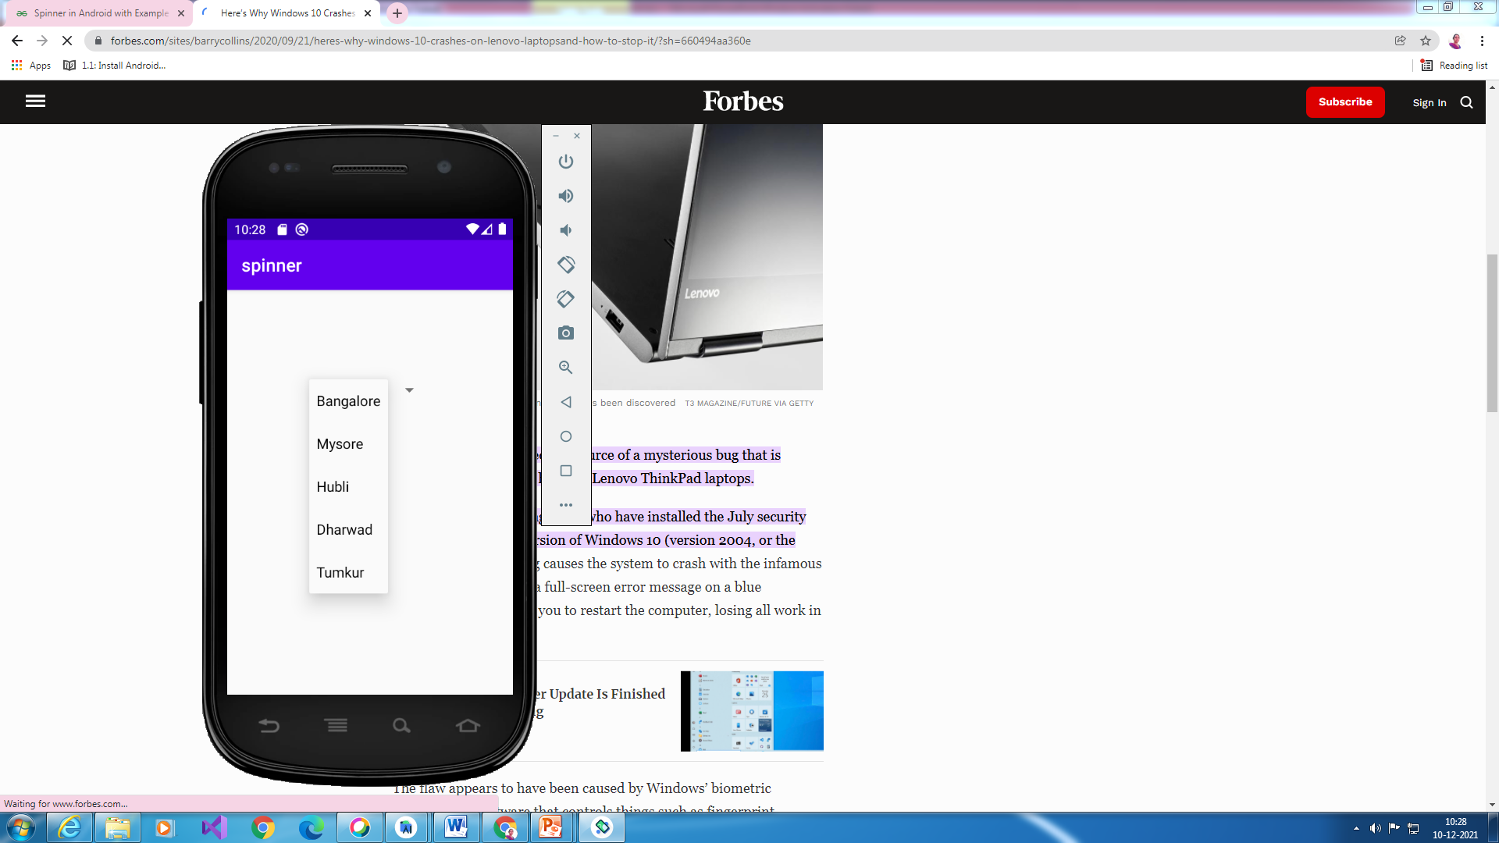

<RelativeLayout xmlns:android="http://schemas.android.com/apk/res/android"  
 xmlns:tools="http://schemas.android.com/tools"  
 android:layout_width="match_parent"  
 android:layout_height="match_parent"  
 tools:context=".MainActivity">  
  
 <Spinner  
 android:id="@+id/simpleSpinner"  
 android:layout_width="wrap_content"  
 android:layout_height="wrap_content"  
 android:layout_centerHorizontal="true"  
 android:layout_marginTop="100dp" />  
  
</RelativeLayout>

package com.example.spinner;  
  
import androidx.appcompat.app.AppCompatActivity;  
  
import android.os.Bundle;  
import android.view.View;  
import android.widget.AdapterView;  
import android.widget.ArrayAdapter;  
import android.widget.Spinner;  
import android.widget.Toast;  
  
public class MainActivity extends AppCompatActivity implements AdapterView.OnItemSelectedListener{  
  
 String[] cityNames={"Bangalore","Mysore","Hubli","Dharwad","Tumkur"};  
 @Override  
 protected void onCreate(Bundle savedInstanceState) {  
 super.onCreate(savedInstanceState);  
 setContentView(R.layout.*activity_main*);  
*//Getting the instance of Spinner and applying OnItemSelectedListener on it* Spinner spin = (Spinner) findViewById(R.id.*simpleSpinner*);  
 spin.setOnItemSelectedListener(this);  
  
*//Creating the ArrayAdapter instance having the city list* ArrayAdapter aa = new ArrayAdapter(this,android.R.layout.*simple_spinner_item*,cityNames);  
 aa.setDropDownViewResource(android.R.layout.*simple_spinner_dropdown_item*);  
*//Setting the ArrayAdapter data on the Spinner* spin.setAdapter(aa);  
 }  
  
  
 *//Performing action onItemSelected and onNothing selected* @Override  
 public void onItemSelected(AdapterView<?> arg0, View arg1, int position,long id) {  
 Toast.*makeText*(getApplicationContext(), cityNames[position], Toast.*LENGTH_LONG*).show();  
 }  
  
 @Override  
 public void onNothingSelected(AdapterView<?> arg0) {  
*// TODO Auto-generated method stub* }  
}